Temasek Polytechnic
School of Informatics & IT

Database Application Development (CIA1C06)

AY 21/22 Oct Semester

Project Part 2

(Database Design)

Name: | Isaac Tan
Admission Number: | 2100902B
Class: | P11

Table of Contents
Introduction 3
The Entity-Relationship Diagram 4
Data Dictionary 5

Introduction
This web application is called “Uncle Eats”, where it displays all the restaurants in Singapore that have been rated and reviewed by customers. It contains a wide variety of restaurants of many different cuisines for the user to see and read the reviews and decide where to eat. The user can filter and sort out the restaurants using a sorting list at the side, such as the restaurant region (North, South, East, West), cuisine type (Japanese, Korean, Western, etc.), star ratings and price ranges, and dietary options (Halal, Vegetarian, Vegan, etc.).
If the user would like to find a specific restaurant or a specific cuisine or a specific dietary option that is not listed in the sorting list, there is a search bar at the top where he can search for these specific details.
For posting reviews, if the user clicks on the post review button without having an account, the register popup will show and he will be tasked to enter his particulars to create his new account, such as his name, mobile number, email address, and username. He will also be asked to fill in his personal information such ass address, or birthdate. However, if he is sensitive about providing this information to the webpage, he can leave them blank. After creating the account for the user to post a review, a text popup will show, and he can type out his review and rate it out of 5 stars and can also attach an image to the review and post it.
If the user made a typo error in his review, he can press the pencil icon on his posted review and edit it again, and if he would like to delete his review, he can do so by clicking on the trashcan icon where a delete confirmation popup will show to ask the user again if he would like to delete the review.
For new users creating a new account, they will be redirected to the home page after creating it where it shows categories of popular restaurants near the user, everyday favorites, and a whole list of other recommended restaurants and for existing users to login, they will just enter their email address and password.
When the user is interested in a certain restaurant, it will display the restaurant name, average rating, price range, food cuisine, dietary option, and the total number of reviews. The user can also sort the user reviews according to highest/lowest rated, or most recent and earliest rating. There is also a restaurant information button where it displays all the information about it, such as restaurant description, opening hours, restaurant hyperlink, restaurant map and location, along with the other information that were displayed at the restaurant page.

The Entity-Relationship Diagram
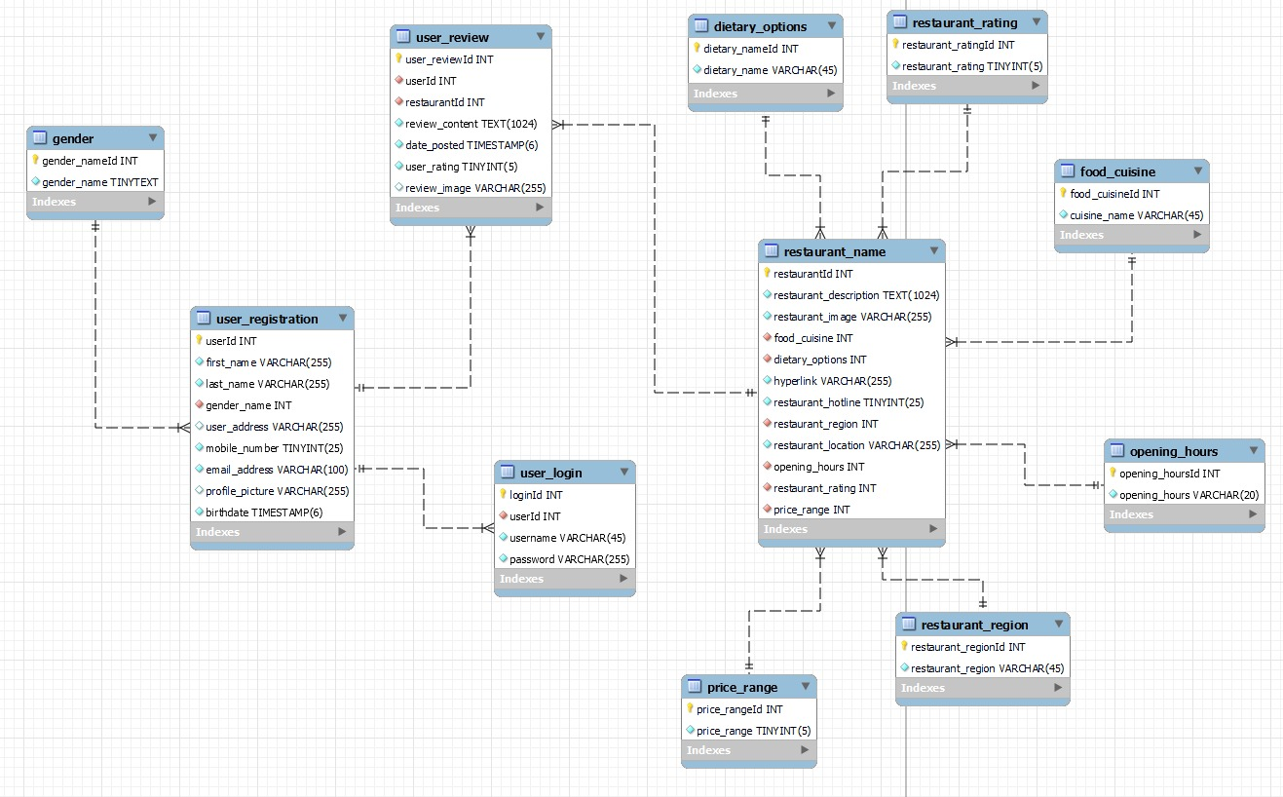

Data Dictionary
Table Name: user_registration
Description: This table contains the user registration information.
Field Name | Data Type | Field Size | Primary/  Foreign Key  (P/F) | Nullable | Unique | Description | Example
userId | INT | - | P | N | Y | ID of user | -
first_name | VARCHAR | 255 | - | N | N | User first name | Dwayne
last_name | VARCHAR | 255 | - | N | N | User last name | Johnson
birthdate | TIMESTAMP | 6 | - | N | N | User birthdate | 2004-07-01
profile_picture | VARCHAR | 255 | - | Y | N | Account profile picture for user | -
gender_name | INT | - | F | Y | N | ID of user gender | -
user_address | VARCHAR | 255 | - | Y | N | User address | Sesame Street 123 Avenue 456 Block 789
mobile_number | TINYINT | 25 | - | N | Y | User mobile number | +65 1234 5678
email | VARCHAR | 100 | - | N | Y | User email | example@123.com

Table Name: user_login
Description: This table contains the information on the user login information.
Field Name | Data Type | Field Size | Primary/  Foreign Key  (P/F) | Nullable | Unique | Description | Example
loginId | INT | - | P | N | Y | Login ID of user | -
userId | INT | - | F | N | N | ID of user | -
username | VARCHAR | 45 | - | N | Y | Username of user | MrBeast6000
password | VARCHAR | 255 | - | N | N | User password | hello123

Table Name: gender
Description: This table contains the information on the user gender.
Field Name | Data Type | Field Size | Primary/  Foreign Key  (P/F) | Nullable | Unique | Description | Example
gender_nameId | INT | - | P | N | Y | ID of user gender | -
gender_name | TINYTEXT | - | - | N | N | Gender name of user | Male

Table Name: restaurant_name
Description: This table contains the information on the list of restaurants.
Field Name | Data Type | Field Size | Primary/  Foreign Key  (P/F) | Nullable | Unique | Description | Example
restaurantId | INT | - | P | N | Y | ID of restaurant | -
restaurant_description | TEXT | 1024 | - | N | N | Description of restaurant | -
restaurant_image | VARCHAR | 255 | - | N | Y | Image of restaurant | -
food_cuisine | INT | - | F | N | N | Food cuisine of restaurant | Korean
dietary_options | INT | - | F | N | N | ID of dietary options | -
hyperlink | VARCHAR | 255 | - | N | Y | Hyperlink to the restaurant | www.shakeshack.com.sg
restaurant_hotline | TINYINT | 25 | - | N | Y | Hotline of restaurant | +65 1234 5678
restaurant_region | INT | - | F | N | N | ID of restaurant region | -
restaurant_location | VARCHAR | 255 | - | N | Y | Map of restaurant location | Tampines Street 23 Block 19 #01-20
opening_hours | INT | - | F | N | N | ID of opening hours | -
restaurant_rating | INT | - | F | N | N | ID of restaurant rating | -
price_range | INT | - | F | N | N | Price of restaurant | -

Table Name: user_review
Description: This table contains the information on the list of restaurant reviews.
Field Name | Data Type | Field Size | Primary/  Foreign Key  (P/F) | Nullable | Unique | Description | Example
user_reviewId | INT | - | P | N | Y | ID of restaurant review | -
userId | INT | - | F | N | N | ID of user | -
restaurantId | INT | - | F | N | N | ID of restaurant | -
review_content | TEXT | 1024 | - | Y | N | User review | This food is good
date_posted | TIMESTAMP | 6 | - | N | N | Date and time when review was posted | YYYY-MM-DD HH:MM:SS  2021-05-04  23:59:59
user_rating | TINYINT | 5 | - | N | N | User rating of the restaurant | 4/5
review_image | VARCHAR | 255 | - | Y | N | User attach image to the review | -

Table Name: dietary_options
Description: This table contains the information on the list dietary options.
Field Name | Data Type | Field Size | Primary/  Foreign Key  (P/F) | Nullable | Unique | Description | Example
dietary_nameId | INT | - | P | N | Y | ID of dietary options | -
dietary_name | VARCHAR | 45 | - | N | N | Dietary category | Halal/vegan/vegetarian

Table Name: food_cuisine
Description: This table contains the information on the list of food cuisines.
Field Name | Data Type | Field Size | Primary/  Foreign Key  (P/F) | Nullable | Unique | Description | Example
food_cuisineId | INT | - | P | N | Y | ID of food cuisine | -
cuisine_name | VARCHAR | 45 | - | N | N | Name of cuisine | Western

Table Name: price_range
Description: This table contains the information on the list restaurant price ranges.
Field Name | Data Type | Field Size | Primary/  Foreign Key  (P/F) | Nullable | Unique | Description | Example
price_rangeId | INT | - | P | N | Y | ID of price range | -
price_range | TINYINT | 5 | - | N | N | Restaurant price range | -

Table Name: restaurant_rating
Description: This table contains the information on the list restaurant ratings.
Field Name | Data Type | Field Size | Primary/  Foreign Key  (P/F) | Nullable | Unique | Description | Example
restaurant_ratingId | INT | - | P | N | Y | ID of price range | -
restaurant_rating | TINYINT | 5 | - | Y | N | Rating of restaurant | 4/5

Table Name: restaurant_region
Description: This table contains the information on the list restaurant regions.
Field Name | Data Type | Field Size | Primary/  Foreign Key  (P/F) | Nullable | Unique | Description | Example
restaurant_regionId | INT | - | P | N | Y | ID of restaurant region | -
restaurant_region | VARCHAR | 45 | - | N | N | Restaurant region | North/South/East/West

Table Name: opening_hours
Description: This table contains the information on the list restaurant opening hours.
Field Name | Data Type | Field Size | Primary/  Foreign Key  (P/F) | Nullable | Unique | Description | Example
opening_hoursId | INT | - | P | N | Y | ID of opening hours | -
opening_hours | VARCHAR | 20 | - | N | N | Opening hours of restaurant | 09:00 – 10:00

